Canadian Association of Rally Obedience Rules Committee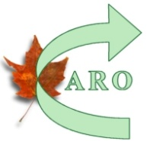
Request for new rule or modification to existing rule. F14

Submitted by:
Name: |  |  | DATE:
Membership # |  | Membership Type : Professional Associate
Email:

New Rule Request Modification Request

If a modification please quote existing rule. Give station number or any other relevant information.

Give reason(s) for modification

For new rule or modification please give suggested wording.

Attach other pages if necessary.
For Rule Committee Use:
Judy Miller
Anthea Young Miller
Linda LaHoullier
Darlene McCuaig
Barb Wright
Returned to submitter for further information____________________________________
Recommended/Not recommended by committee__________________________________
Submitted to Executive:______________________ Executive Response___________________
If approved – date of approval______________ Date of inclusion_________________________

